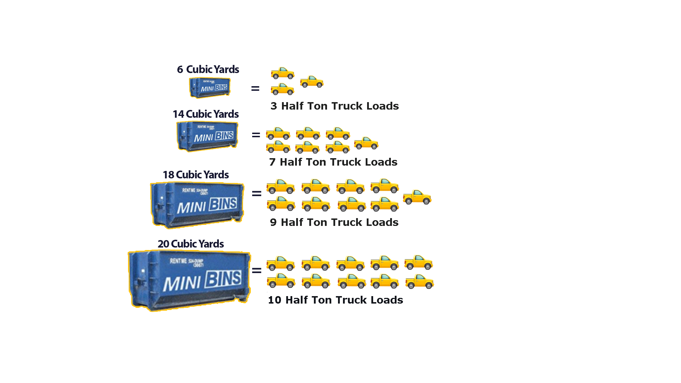



***Disposal Services and Storage Solutions***

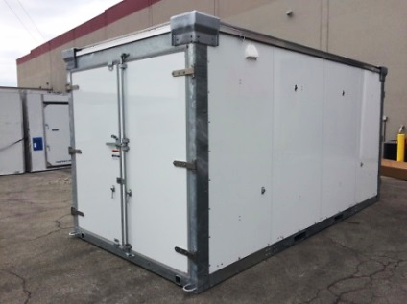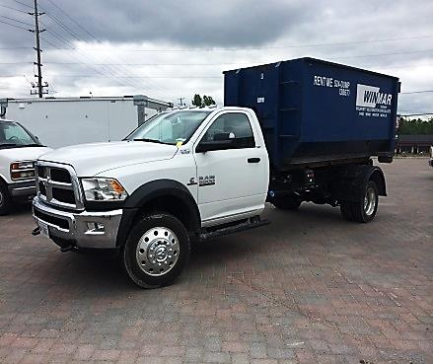**zp**

**Rental Fees**

**​**

**Option 1 (6-18 CUBIC YARD):**

**$400.00 + HST**

***(Includes up to 2 tons- tipping fees - 5 day rental)***

**​**

**Option 2 (20 CUBIC YARD):**

**$500.00 + HST**

***(Includes up to 2 tons- tipping fees - 5 day rental)***

**​**

**Additional tipping fees - $80/ton**

***\*Outlining areas are subject to a varying delivery fee depending on distance\****

**​**

**Best rates guaranteed.**

***Quick, Easy Service***

***Portable Storage Containers***

***2 Acres of secured outdoor storage***

${14,000}^{2}$***Climate controlled storage***

***With our swappable flatbeds, we also offer on-site storage for more permanent storage options, as well as inside our facility and off-site locations.***

*SUDBURY’S ORIGINAL MINI BINS*

***Available 24/7***

*The Quick and Simple Solutions for Your Disposal Needs!*

***Best Rates in Town!***

***CALL US***

***(705) 524-DUMP (3867)***

[**www.SudburyMiniBins.com**](http://www.SudburyMiniBins.com)

**sudburyminibins@vianet.ca**

